First, we have check Whether git is installed or not in our system
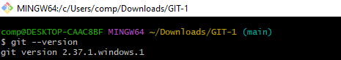
To start the git, we have command as git init
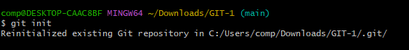
To create file and add into git
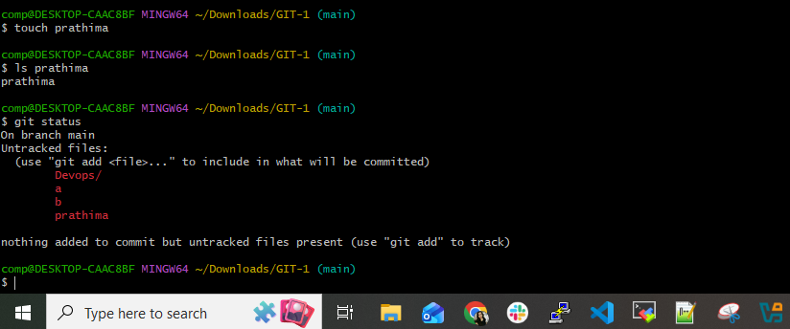
To Add user name and email to configuration list
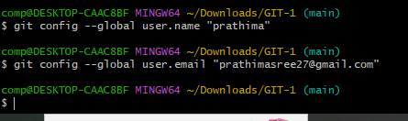
To add multiple files into git
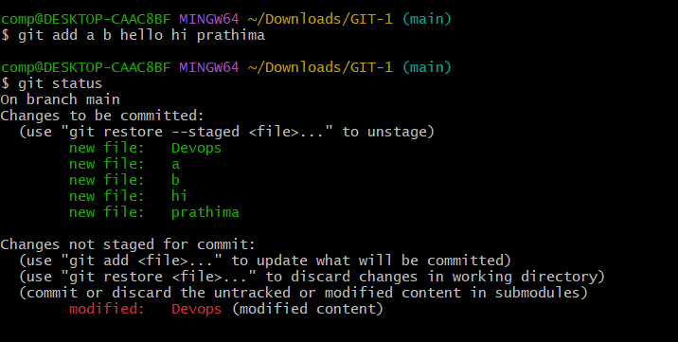
After adding username and email check in configuration list as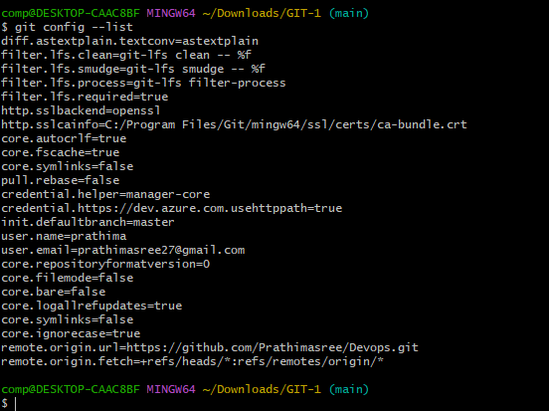 Check configured remote repository

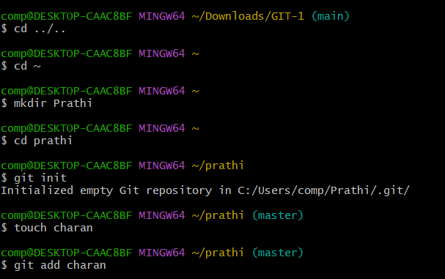
How to push our files into GitHub repository
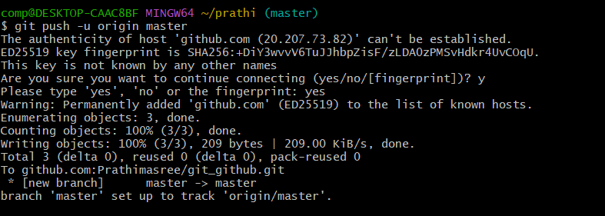
How to pull our files into GitHub repository
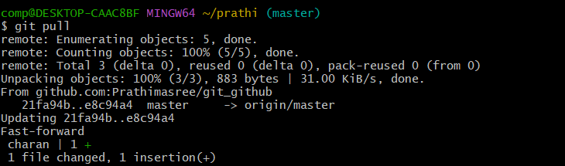
How to Check configured remote repository
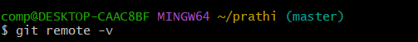

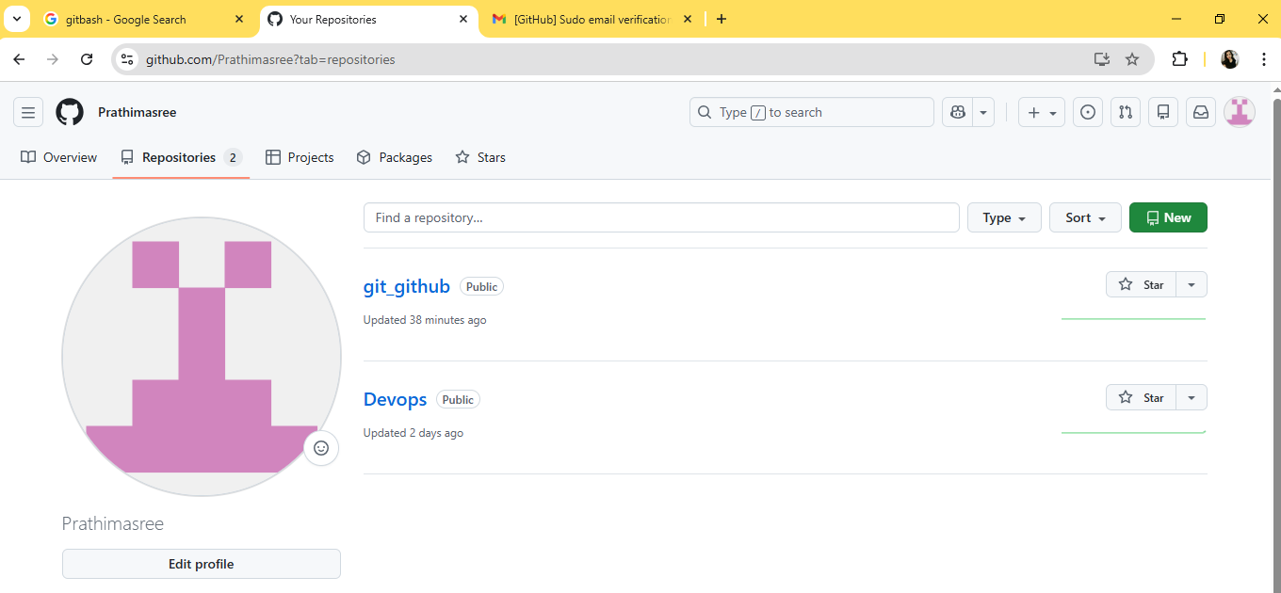
Click on create a new repository and give Repository name , choose visibility as public and finally click on create repository.

Click on SSH and copy URL and for remote connection.
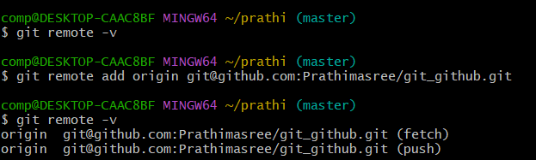
For ssh connection
